- The Monetary Policy Committee narrowly voted 5-4 to cut Bank Rate by 25bps to 4.25% at its May meeting. Of the dissenters, two voted for a 50bps cut and two for no change.
- The MPC's core message was more hawkish than markets anticipated, but is in line with our baseline. We still anticipate two further 25bps cuts in H2, taking Bank Rate to 3.75% by year end.
- Maintaining its "gradual and careful" guidance and suggesting today's decision would have been finely balanced without US tariff announcements suggests the chances of a June cut are low.
- Though the MPC surprised markets with its hawkish tone, it might not last. We expect GDP and inflation to surprise on the downside. That the MPC hasn't managed to form a consensus on the impact of US tariffs also implies potential for an abrupt change of view.
The Bank of England's Monetary Policy Committee voted 5-4 to cut Bank Rate by 25bps to 4.25% at today's meeting. Two members – Swati Dhingra and Alan Taylor – voted for a 50bp cut, whereas two others – Huw Pill and Catherine Mann – voted for no change.
In recent weeks, several MPC members had suggested they expected recent US tariff announcements would weigh on the growth outlook and some had also suggested the fallout from US trade policy would lower inflation. In response, market expectations for interest rates had dropped significantly to the extent that a May cut was seen as a done deal and a June cut was a 50-50 call. But the MPC's messaging was more hawkish than markets anticipated, triggering some chunky movements in market pricing for June.
The hawkish message came from three sources. First, the MPC's growth forecast was little changed. A small upgrade to this year reflected historical revisions and a stronger-than-expected Q1. The BoE's 2026 forecast was only downgraded by 0.25ppts and leaves the BoE above consensus and well above our own projection (Chart 1). When questioned on their relatively relaxed view in the press conference, BoE officials argued that a large part of the negative impact of US tariffs would be mitigated by looser financial conditions and lower oil and fuel prices.
Chart 1: The BoE's made limited downgrades to its growth forecast, which looks too optimistic
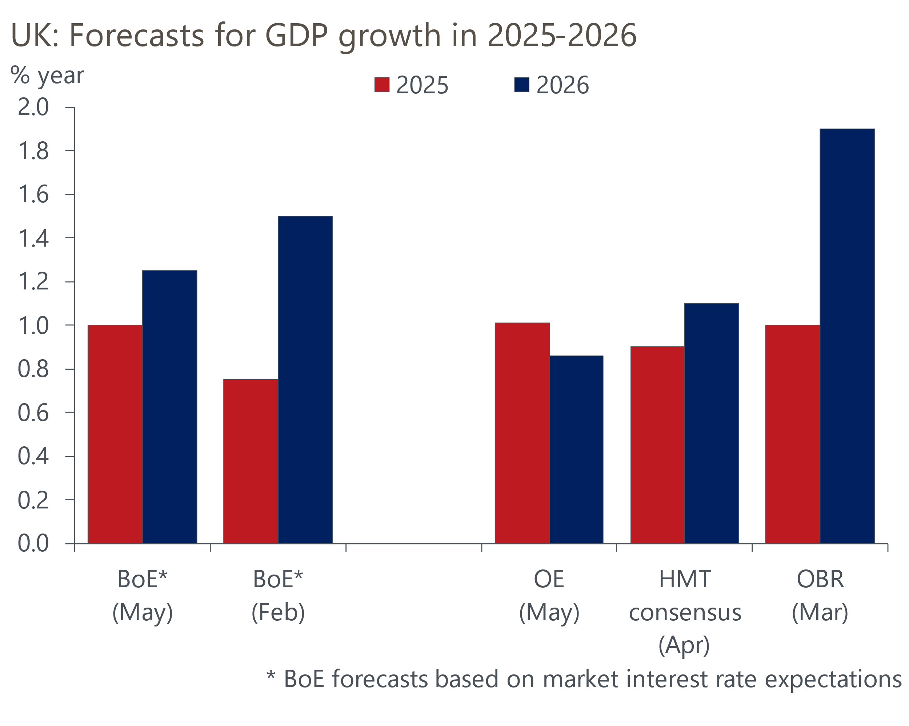
Sources: Oxford Economics, BoE, HMT, OBR

Second, the minutes reported that for most of those voting for a 25bp cut this month, the decision between a cut and no change would have been finely balanced were it not for US tariff announcements. When the MPC previously cut during this cycle, the minutes had not suggested that the decision was close, so the wording used in the May minutes looks like a deliberately hawkish signal.
Third, the MPC opted to retain its guidance that it would take a "gradual and careful" approach to loosening policy. In February, the MPC had emphasised the importance of this wording – leaving out either or both words would have sent a clear signal that the MPC was prepared to cut faster. Retaining this wording implies continuing the well-established cut-hold tempo is the most likely scenario over the near-term, with the bar to another cut in June or September now looking high.
The one dovish signal was the MPC's new inflation forecast, which was lower than February's projection (Chart 2). In the near-term, this was a story of lower oil and gas prices and a stronger pound. In the medium-term, the MPC expects slightly more spare capacity to emerge than before, despite the forecast being based on a market curve that was nearly 60bps lower than the February forecast in 2026. That the MPC expects inflation to be close to 2% at the two- and three-year horizon is an implicit endorsement of the recent dovish shift in market pricing.
Chart 2: We think the MPC's near-term inflation forecast looks too high
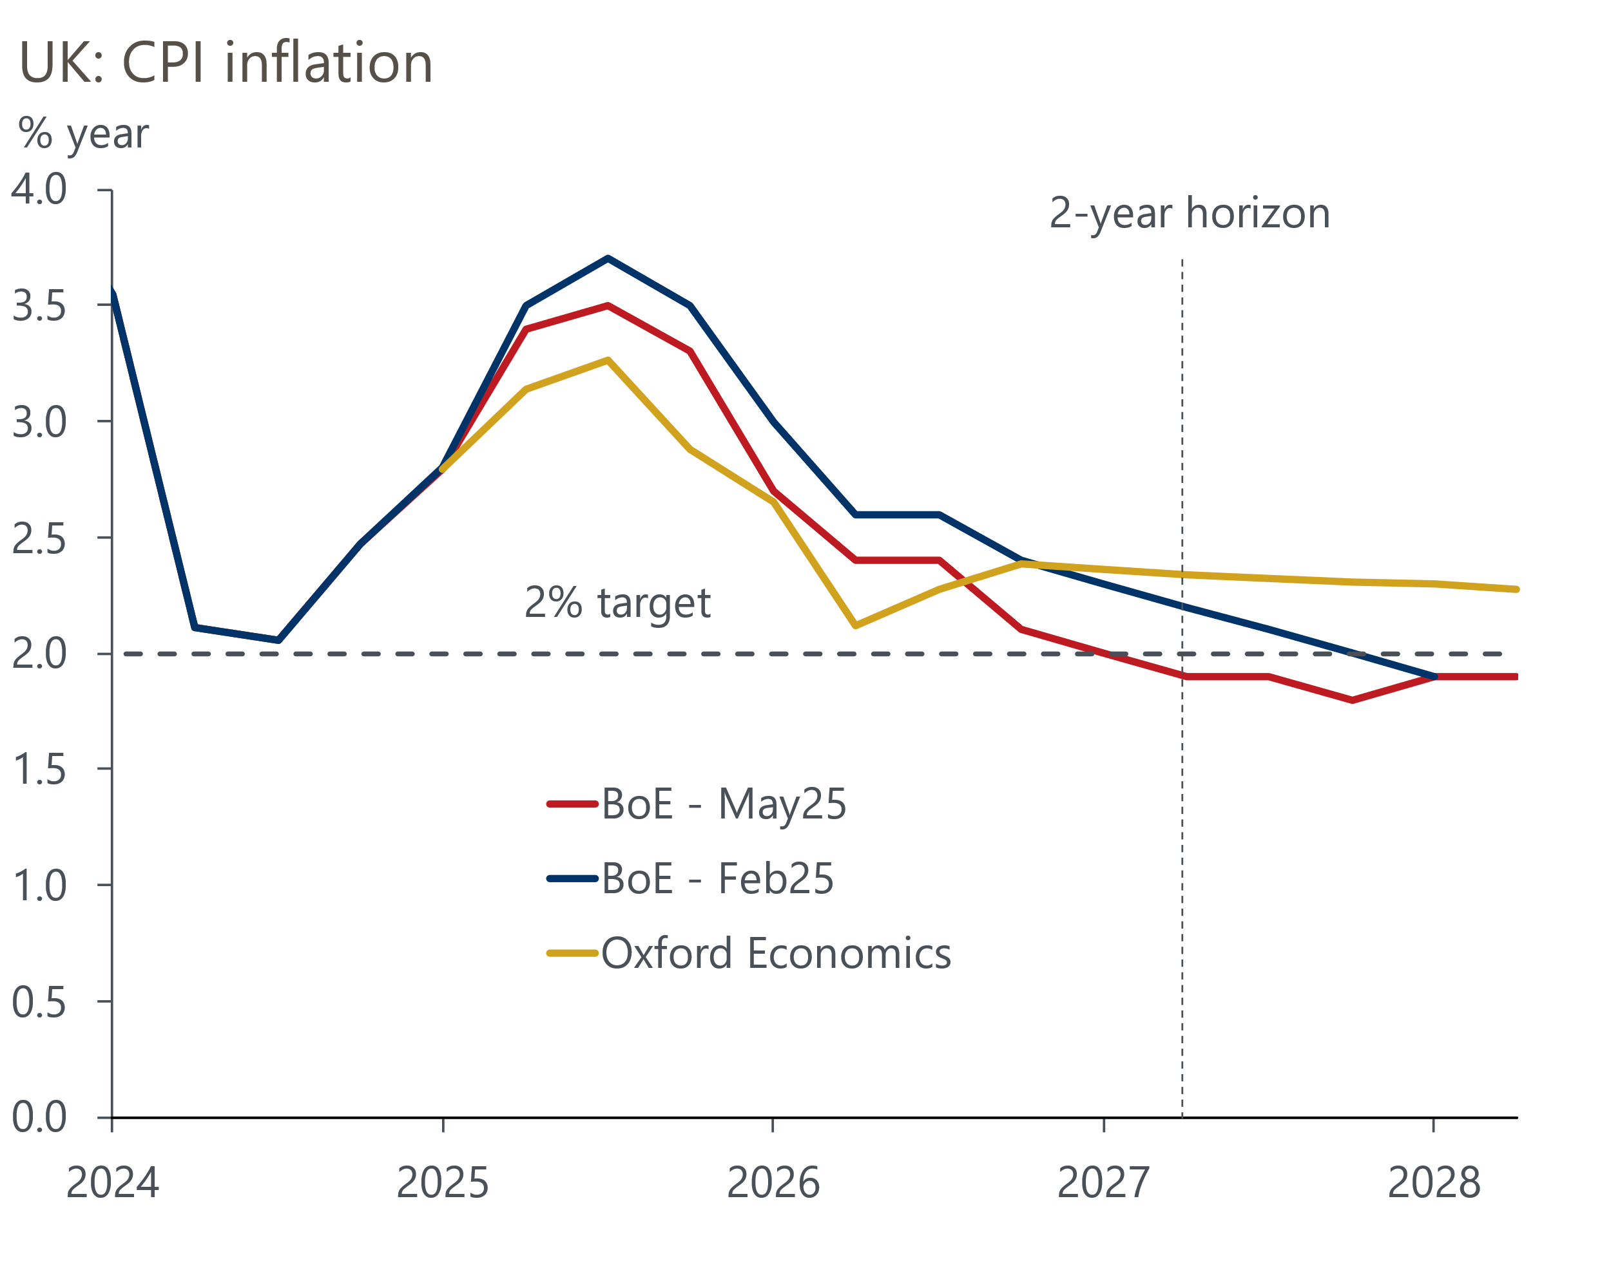
Sources: Oxford Economics, Bank of England Monetary Policy Report

We stick with our forecast of two more 25bps cuts in H2 2025
Coming into today's meeting, we argued that US tariff announcements represented a demand shock that called for monetary policy to be loosened more quickly. But we thought the MPC's concerns about supply would likely lead them to adopt a more cautious approach than they should.
We drew three conclusions from today's meeting. First, the MPC has not managed to come to a consensus about how to think about the tariff shock. Second, the average view, shown in the MPC's baseline forecast, is that the scale of the demand shock will be relatively limited. And third, we were right to think that concerns about supply were still at the forefront of many committee members' thinking.
The clear pushback against cutting more quickly means we stick with our call that the cut-hold tempo will continue, with 25bp cuts in August and November taking Bank Rate to 3.75% by year-end. Based on our modelling, this would still leave policy in restrictive territory, and we expect the MPC to continue to gradually cut interest rates in 2026.
But the MPC's struggle to form a consensus and its repeated references to heightened uncertainty means we think the chances of an abrupt change of view are high. Its concerns about supply – something that is virtually impossible to measure in real-time – and the uncertainty around the inflationary impact of April's increases in employers' national insurance contributions and the national living wage add to the potential for volatility. Though today's messaging was more hawkish than markets anticipated, we wouldn't rule out a dovish switch, particularly if growth and inflation start to surprise to the downside.

Key passages from the MPC minutes
“At this meeting, five members voted to reduce Bank Rate to 4.25%. Prior to the latest global developments, most members in this group had judged that this policy decision would be finely balanced between no change in Bank Rate and a further reduction. Although the current impact of the global trade news should not be overstated, the news was sufficient for those members to judge that a reduction in Bank Rate was warranted. This level of Bank Rate would still leave the stance of monetary policy sufficiently restrictive to bear down on inflationary pressures, were they to re-intensify. For the other members in this group, even in the absence of the latest global news, the case for a reduction in Bank Rate at this meeting had been fairly clear. Underlying domestic disinflation was progressing as expected and monetary policy restrictiveness was bearing down on activity."
Our interpretation: The key message is that the decision would have been finely balanced were it not for US tariff announcements. The minutes of earlier meetings hadn't suggested decisions were this close, so the comments appear to set a deliberately hawkish tone.
"Two members preferred a 0.5 percentage point reduction in Bank Rate at this meeting based on the outlook. The most significant contributions to the expected pickup in inflation would come from one-off tax and administered prices and past energy shocks. Incoming wage settlements had so far been close to the Agents’ annual pay survey figure for the end of 2025, and were approaching sustainable rates, while consumer spending remained weak and investment subdued. Along with domestic demand shifts and emerging slack, recent global developments in energy and trade policy pointed to potential downward risks to global growth and world export prices. In the medium term, a continued monetary policy stance that was too restrictive risked inflation deviating from the 2% target on a sustained basis and the opening up of an unduly large output gap. Given this balance of risks, a less restrictive policy path was warranted."
Our interpretation: This risk management approach has long been advocated by Swati Dhingra. Alan Taylor has also hinted that the dominance of downside risks demands a more aggressive approach than some of his peers have advocated.
"Two members preferred to hold Bank Rate at 4.5%, recognising that short-end market interest rates had already eased by around 40 basis points since the MPC’s previous meeting. For these members, the labour market was proving more resilient than expected, business surveys signalled continued inflationary pressures, and household expectations of inflation had firmed. All these indicators pointed to continued inflation persistence owing in part to structural rigidities on the supply side of the economy. Holding Bank Rate unchanged at this meeting would ensure that monetary policy remained sufficiently restrictive to weigh against stubborn inflationary pressures."
Our interpretation: BoE Chief Economist Huw Pill has been the most hawkish committee member in recent months, but in February he had still voted to cut. In that context, his vote to hold this time, despite the deteriorating global outlook, is significant. Pill is clearly very worried about the weakness of supply and though others have sympathy for his concerns, they have continued to prioritise demand so far. Mann's voting has been erratic – a long-time hawk, she voted to cut by 50bps to 4.25% in February but then voted to hold rates at 4.5% in March and May. Mann appears to believe that changes in market pricing meant a Bank Rate cut was no longer needed, but we continue to find it hard to comprehend her reaction function.
"Based on the Committee’s evolving view of the medium-term outlook for inflation, a gradual and careful approach to the further withdrawal of monetary policy restraint remained appropriate. The Committee would continue to monitor closely the risks of inflation persistence and what the evidence may reveal about the balance between aggregate supply and demand in the economy. Monetary policy would need to continue to remain restrictive for sufficiently long until the risks to inflation returning sustainably to the 2% target in the medium term had dissipated further. The Committee would decide the appropriate degree of monetary policy restrictiveness at each meeting."
Our interpretation: In the February press conference, Governor Bailey said the choice of "gradual and careful" was the product of lengthy discussions. Retaining this guidance suggests the chances of the MPC adopting a more aggressive approach to cutting interest rates are low for now.

